Training Workers for Christ
Terry Messenger

Problem:

SEC Director can only reach 1 church every four years. And Conference sponsored training events are sporadic and only reach a few. There needs to be ongoing training programmes in churches in order for effective evangelism to take place on a regular basis.

Solution

Train Pastors/members to run programmes in their local districts resourced and supervised by the SEC

How will it work?

Trainers will receive ongoing training from the SEC and they will in turn train their local districts. Travelling expenses will be provided by the SEC. Reports should be sent to SEC Director.

Type of training

Seminars, one to one, groups and actual field work. The best way to learn is by actually doing it!

How to implement it

Liase with Pastor/Elders for best time slot – also AYS leader. Find out who wants to be trained in your local area.

Why Training?

Many members of the church lack the basic skills in leading a person to Jesus.
- lack of confidence
- lack of training
- lack of opportunity


Inactive Members

The way the church has proceeded has not produced the quality of people or the numbers of people to perform what Christ has commanded. Studies show that the vast majority of believers, perhaps as many as 98 percent are neither confident nor effective in their witness for our Savior. Bill Bright “Witnessing Without Fear”

Church Statistics UK

Jehovah Witnesses – 120,000

Mormons – 180,000

SDA’s – 29,000

The main strength of the Jehovah Witnesses is that they run regular training programmes at the local level.

Why Training?

Too much clergy dependency

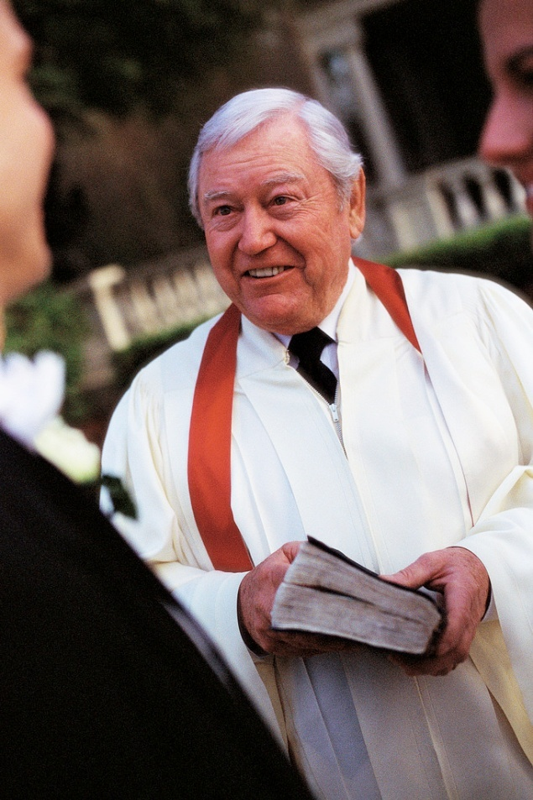

High apostasy rate

Lack of nurture/discipleship

There is need of coming close to the people by personal effort. If less time were given to sermonizing, and more time were spent in personal ministry, greater results would be seen. MH 143

Challenges

Materialism


Modernism

Postmodernism



True Success

“The test of any work of evangelism thus is not what is seen at the moment, or in the conference report, but in the effectiveness with which the work continues in the next generation. Similarly the criteria on which a church should measure its success is not how many new names are added to the roll nor how much the budget has increased, but rather how many Christians are actively winning souls and training them to reach the multitudes.” Robert Coleman

“Many would be willing to work if they were taught how to begin” (Christian Service, p. 59).

The Multiplication Principle

“Discipling leads to reproduction and finally multiplication, which are God’s design and method to reach the world.” Bill Hull

Jesus trained a few disciples for three years and there did not appear to be any apparent fruit after that period of time, but after His death and resurrection, the trained apostles turned the world upside down–that is multiplication on a grand scale!

“Spiritual growth by multiplication is much more effective than growth by addition. Lets say you led only one person to the Lord every year and you spent the whole year teaching this new Christian. If you taught him to do the same, the world would be totally evangelized in 34 years.” Michael Bronson

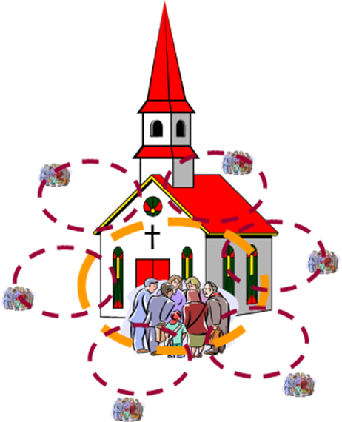

Jesus’ Strategy

"Though He (Jesus) did what He could to help the multitudes, He had to devote Himself primarily to a few men, rather than the masses, so that the masses could at last be saved. This was the genius of His strategy.”
Coleman



“If Jesus found it necessary to stay almost constantly with his few disciples for three years, and even one of them was lost, how can the church expect to do this job on an assembly line basis a few days out of the year?” Coleman

Why are fruitful, dedicated, mature disciples so rare? The biggest reason is that all too often we have relied on programs and materials to do the job. It takes time to make disciples, but the results are lasting.

“It did not matter how small the group was to start with so long as they reproduced and taught their disciples to reproduce . . . As simple as it may seem, this is the way the gospel would conquer. He (Jesus) had no other plan.” Coleman



Early Church Methodology

Our Lord could have spent all His time in evangelism. But he spent much time in teaching those closest to Him. Evangelism, discipleship, and spiritual multiplication were intertwined in everything the Lord Jesus and the apostle Paul did, and this is why the early church grew so dramatically.

Why did the disciples go everywhere preaching the Word? Because they had been raised in an atmosphere of witnessing. They assumed that it was the normal thing to do. It was all they knew of Christianity. They had been taught and had been given examples.

Local Training

People crowd the bookstores to get the latest from the Christian publishers; they crowd the evangelical seminaries and the Bible institutes for some Bible training, and they crowd the seminars and lectures by well known speakers and visiting lecturers. But the answers to many of these milling masses, who are clamoring for spiritual reality, could be found in a quiet, solid, ongoing program of discipleship training in their local churches. Leroy Eims, “The Lost Art of Disciplemaking.”



Importance of Training

It is training, education, that is needed . All the preaching in the world will not make men feel deeply the need of perishing souls around them.
Ellen White, Testimonies for the Church,vol 9 116,117.

Systematic Training

There is no denying that the Jehovah Witnesses’ systematic training of members in personal evangelism and consistent field work, going out in pairs, training actually taking place in the field, has produced results, and the indigenous people have been won through these means.



Qualifications needed to Share Jesus Effectively

Spirituality
Teaching skills
Patience
Perseverence
Flexibility
Good relational skills
Humility/teachability

Methodology

1. Take trainee with you to observe
2. Ask trainee to conduct interview/Bible study and you observe
3. Critique their performance
4. Trainee able to go out alone
5. If they have the gift they can train somebody else

Critiquing

Be tactful
Mention positive points first
Mention negative points in the middle but always end with positive point
Always be encouraging

Topics

Obtaining Decisions for Jesus
Running Small Groups
Characteristics of a Healthy Church
Discovering Spiritual Gifts
Discovering Evangelism Style
Finding Contacts
Visiting Contacts
How to Conduct Bible studies
Discipling new members
Conducting Public Evangelism
Preparing the Church for evangelism
Motivating members to witness
Developing lay-preachers
Reaching people of other faiths
Running community based programmes
Reclaiming lost members
Relating successfully with people
Presenting the gospel
Witnessing in the workplace
Effective teaching methods
How to interpret the Bible correctly

This is not an exhaustive list. There are many ways to share Christ!

