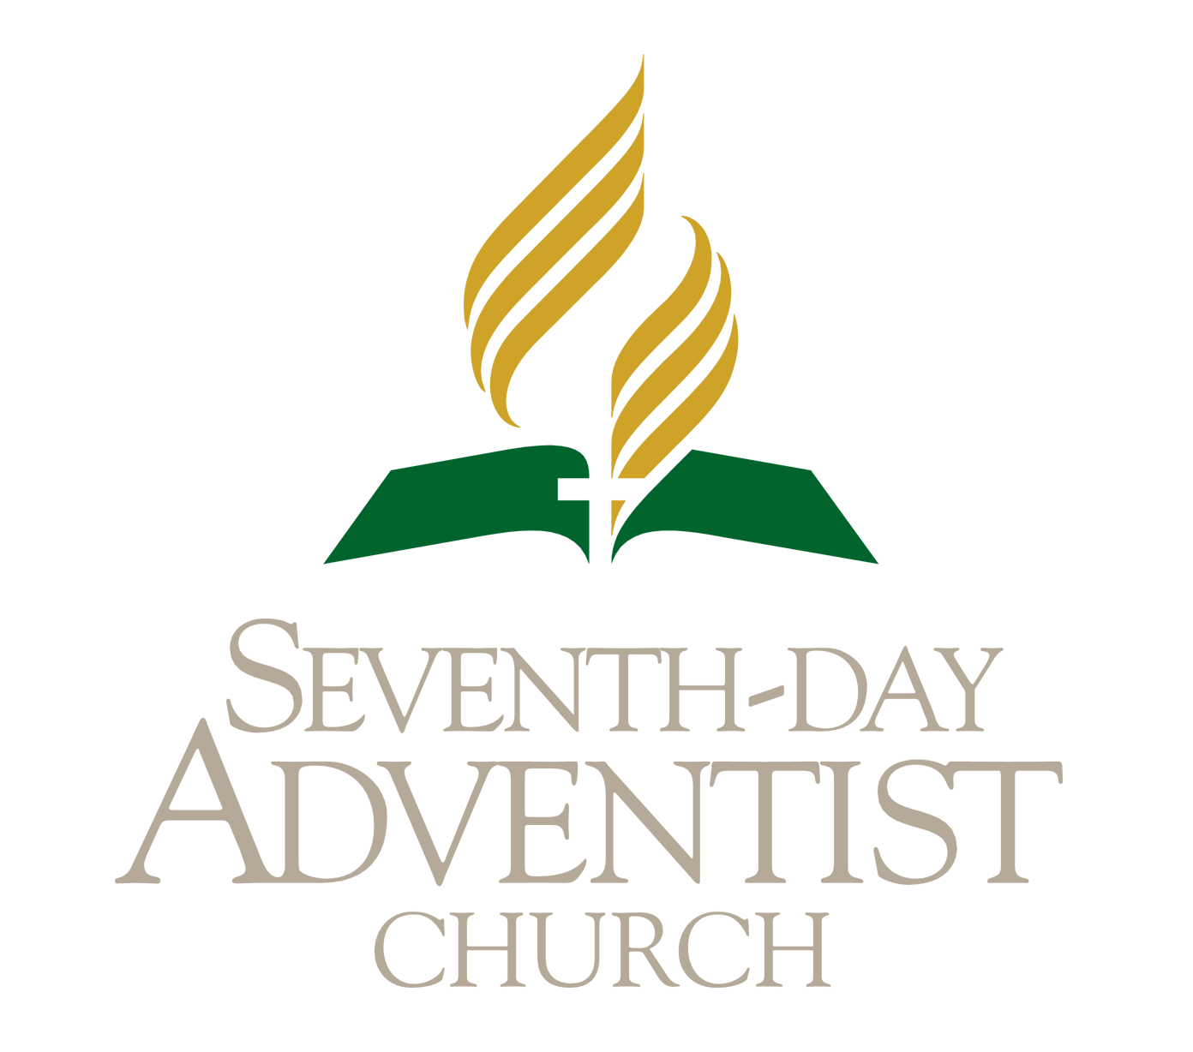

SEC Response Guide

08
Fall
How to deal with Disaster when it strikes

South England Conference of Seventh-day Adventists
South England Conference Disaster Response Guide
SOUTH ENGLAND CONFERENCE DISASTER RESPONSE GUIDE
Preface
Every year thousands of people are displaced because of disasters and unfortunately these events adversely impact Seventh Day Adventist Churches around the world. The church has always been deeply involved in ministry to victims of disaster.
What can be done to provide a unifying and effective response? What can individuals do and what is the role of the local church and conference? This guide aims to make available to every church member the information needed to develop and prepare an effective service in disasters.
The Community Ministries Department is grateful for the support given by the members to relieve the distress and the trauma which many people are exposed to in their time of crisis. Suggestions for improvement to this booklet are welcome. It is hoped that this guide will enable the church, through the community ministries department to enhance the assistance given by the church to disaster victims.

Contents Page
Introduction: Why Disaster Relief? 5
Encouragement for the Volunteers 7
Reporting of the Disaster within the SEC 8
Preparing the Area for Disaster 9
Response Planning 16
A Planning Team 17
Disaster Operation Plan 18
Stockpiling of Materials 18
Initial Response to Disaster 17
Flooding Happens 18
After Floods 18
What to do before flooding occurs 17
Flooding Happens 18
After Floods 18

Member's Personal Preparation 17
Flooding 17
What to do before flooding occurs 17
Flooding Happens 18
After Floods 18
How to Prevent a Fire 19
If a Fire Happens 19
After a Fire 20
Terrorism 20

Introduction: Why Disaster Relief?
We are in a time of earth’s history when disasters are occurring everyday. Millions are losing their lives. Students of Bible prophecies recognise that the increasing disasters are indicative of the signs of the imminent return of Christ. There will be famines, earthquake and epidemics in many places (Matthew 24:7). Many have testified that the disasters seem to be increasing in both in destructiveness and frequency. However as a Christians we have an obligation to help those who are in distress.
E.G. White in the book Welfare Ministry pg. 137 suggests that, ‘we should be ready to render immediate assistance to those who are under severe pressure’
During the aftermath of the disaster the victims’ resources are very low whether it is emotional, physical or spiritual. It is in these times help is needed the most to relieve the stressors of uncertainty, fear and worry. The emotional support is equally important as the spiritual and physical. The church has always been involved in providing these services
As the disasters increase in frequency and intensity the church needs to be more organised to support and do much more not only to church members but also to communities. The public has come to depend on faith groups. In some areas we are known for the distribution of clothing, food, bedding and some household supplies, however we can do much more. It is the personal attention to the three dimensions of man - mind, body and soul which impacts the victims; as there is always a psychological and social impact on the victims/survivors.
For the Community Ministries department to develop in this area of disaster relief the following are needed:
- A place to store the emergency supplies: blankets, tents, clothes, bedding utensils
- A vehicle for transporting the provisions during the emergency
- A mobile unit to provide hot meals
This guide aims to inform, to educate and assist you to prepare for some emergencies. It is designed to assist volunteers to engage in disaster relief. It may act as a catalyst for some to be more involved in this ministry of compassion. The material in this guide has been obtained from many sources including my experience in disaster relief. It is an opportunity to please God as the needy people are served in love

Encouragement for the Volunteers
Read the following bible texts
- Isaiah 58:6, 7
- Mathew 25:31-46
- Luke 10:30-37
- James 2:15, 16
- 1 John 3:17
The following are 6 quotations from E.G. White will encourage volunteers to seek to give more than material aid
- The precious Saviour will send help just when we need it (The Great Controversy pg 633)
- The Lord longs to give you understanding in temporal as well as spiritual matters. He can sharpen the intellect. He can give tact and skill. Put your talents into the work, ask God for wisdom and it will be given you. (Christ Object Lesson pg 146)
- We may have all the same help that Christ had, we may have the same strength for every emergency (Testimonies to Ministers pg 386)
- He, the Saviour never fails to give us the help we need (Desire of Ages pg 336)
- Christ is our only hope... we may take Him at His word and make Him our dependence. He knows just the help we need and we can safely put our trust in Him (Testimonies to Ministers pg 486)
- He is able and willing to bestow upon His servants all the help they need (Ministry of Healing pg 482)
Reporting of the Disaster within the SEC
- The individual must first inform the Community Ministries President / Area Coordinator / First Elder of the disaster if these named personnel are not aware
- A needs assessment must be made as soon as possible following the event
- Be ready to provide any information requested including name, location, the nature of the emergency, urgent supplies, and injuries or deaths
- The Community Ministries Director of the South England Conference should be contacted as soon as possible
- Disaster relief should begin within 3 days of the disaster and completed within 3 weeks
- Request for assistance will only be considered from the persons named in guideline 1
It is anticipated that it may not be necessary to implement 3-4 as the situation / disaster can be managed locally by the church or area
Preparing the Area for Disaster
- Each area should have a disaster planning team
- Each area should have a named place of refuge to assist in accommodation
- All pastors and members should be aware of the procedures when managing an emergency, for example who should be contacted
- A list should be made of all the church members who will be willing and are available for service during a time of disaster
- All the willing volunteers should be CRB checked, hold a community ministries identification card and should have a current first aid certificate or be first aid aware
- A disaster sign kit should be available - armbands, disaster centre identification signs, signs in the centre to the services provided
- At local church/area level it is good practice to have a current list of emergency contact numbers easily accessible. Organise this list based on the type of emergency as different individuals and entities will need to be contacted
- Each home should have a first aid kit and a disaster supply kit

Response Planning
1. A Planning Team
Each area should have a disaster master planning team especially if the church is situated in a disaster prone area. This team should consist of 3-5 members. The team members are not necessarily appointed because of the office which they hold in the church but chosen on the ability to plan, organise and be able to carry out the disaster operation. However the Area Federation President of the community ministries and/or a community ministries leader as well as the personal ministries leader should be considered as possible members of the team.
A disaster relief service should be a special project of the community ministries in each church.

2. Disaster Operation Plan
A written operation plan should be drawn up. This should include the name of the person who will be in charge of the operation and the names of those who will manage specific tasks. These individual should be aware of their role and responsibilities. There should be mock disaster exercise to see how effective the plans will be and the opportunity for role practice.

3. Stockpiling of Materials
The response may be varied depending on the felt need. However the following resources items will be distributed if required
- Bottled water
- Bedding – blankets, sheets, pillows
- Tents
- Kitchen utensils: cups, spoons, plates these can be disposable facilities for washing up may be limited
- Clothing
- A clean up service – a group of people to assist others in cleaning up
- Comfort kits – toiletries & a towel, cleaning up materials
- Counsellors
- Baby layettes – pampers, wipes
- Friendship kits (clothing, shovels, ropes)

4. Initial Response to Disaster
- Assessment
- Internal communication
- External communication
- Media

5. Volunteers Role and Responsibility to be completed
- Leaders
- Who is in charge?
- Duties of the director and assistants
- The interviewer
- Counsellor
- Volunteers

6. Training Classes
The Red Cross provides training. The South England Conference provide the following training:
- First Aid
- Medical help
- Food hygiene
- Disaster response training
However the members should be equipped and should be willing to respond to give timely and quality assistance and when community resources are desperately needed to relieve human suffering.
No two disasters are exactly alike. Volunteers need to be flexible in meeting the different situations and needs. Being prepared enables one to provide a better and more effective service.

7. Forms for Effective Disaster Planning
- Registration volunteer form (RVF)
Name: ____________________________________ Age: _______
Gender: Male Female
Contact number: _________________________________________
Postal address: __________________________________________
_______________________________________________________
Email: _________________________________________________

- Disaster planning survey (DPS)
In disaster zones this should be revisited annually.
The Disaster planning team would like you to complete the following form to let us know of your availability should a disaster strike in the neighbourhood.
Types of Services needed at time of Disaster
Please indicate those areas in which you would be able to serve. List as many as possible:
Service | Indicate specialism (please tick)
Food preparation at the centre/ or home
Food serving
Vehicle driving
Guard duty
Clothing distribution
Reception
Interviewing and information
Medical care (indicate speciality)
First Aid
Painting
Electrical
Plumbing
Carpentry
Clean up
Working with children
Providing temporary accommodation
Shelter management
Transport
Public relations/ communication
Recruiting volunteers
Liaison between agencies

C). Availability
Please indicate the day of the week and the time you will be available:
Day | AM hours | PM hours
Sunday
Monday
Tuesday
Wednesday
Thursday
Friday
Saturday

D) Vehicle availability
Name of Driver: _________________________________________
Contact number: _________________________________________
Postal address: __________________________________________
_______________________________________________________
Work number: ___________________________________________
Type of vehicle: __________________________________________

Days of the week vehicle can be used:
Mon / Tue / Wed / Thu / Fri / Sat / Sun

E) Family Requisition
Disaster location/address: _________________________________
_______________________________________________________
____________________________ Date: _____________________
Family Name: ___________________________________________
Address: _______________________________________________
_______________________________________________________
Number in family: _________ (please input details below)
Gender | Age | Sizes

Materials to be given
Number of clothing
Number of pieces of bed linen
Number of sheets
Number of towels
Estimated value of groceries | £

Name of volunteer: _________________________________
Signature of volunteer: _________________________________
MEMBER’S PERSONAL PREPARATION
Start preparing today before a flood happens! If you live in a flood risk area do what you can now to prepare for a flood. Don’t wait until it happens, you may not have time.
The following actions will help you to be prepared.
- Check your insurance cover - ensure it covers flood damage
- Know how to turn off your gas, electricity and water mains supplies.
- Prepare a flood kit of essential items such as a torch, a portable radio
- As a family agree where you will go and how to contact each other.
- Think about what you can move to a safe place now (for example photo albums, family videos and treasured mementos/possessions).
- Think about what you would want to move to safety during a flood (for example pets, cars and furniture).
- Create a list of important contact numbers including Flood line 0845 988 1188.
- Be first aid aware

Flooding
- Always listen carefully to the advice of the emergency services – and follow their instructions.
- Make a list of your important telephone numbers and write down your plan of action including reminders of what to take if you need to leave your home quickly.
- Lock all doors and windows if you have to leave your home.
- Tell someone who is close to you where you are and where you are going.
- Keep your mobile phone and charger with you at all times.
- Try and remain calm – it really helps in an emergency.
- Check to see if your neighbours need help.
- Think about how you can help your neighbours and vulnerable or elderly people.
- Decide what you can do to protect your pets and animals
(British Red Cross website)

What to do before flooding occurs
- Call “Floodline” on 0845 988 1188 to find out if your home is at risk. If it is, there are many ways to prepare well in advance. The Environment Agency gives advice on ways to protect your home from flooding.
- Choose furnishings that are easy to remove or store at a higher level, such as rugs rather than carpets.
- Unfilled sandbags and sand can be purchased from builders’ merchants. Remember if there is a flood, demand may exceed supply as people rush to buy them.
- Prepare an emergency kit including emergency numbers, insurance policy, first aid kit, torch and water. Have a list of irreplaceable items to make safe – and keep important personal documents in a sealed bag.
- Tune in to the local radio/TV for updates. If you can, move any vehicles to higher levels. Alert your neighbours, particularly elderly people.
- Pack essential items you will need if evacuated – medication, clothing, toiletries and items for children. Empty freezers and refrigerators, leaving doors open.
- If you have time, take photographs before you leave. This may help with later insurance claims. Turn off the mains power and water, and take mobile phones and chargers with you. Put sandbags in toilet bowls to prevent sewage back-flow. Shut windows, lock doors – take pets.

Flooding happens
- When flooding happens, stay safe.

Don't walk, swim or drive through floodwater – just six inches of fast-flowing water can knock you over and two feet will float a car!
- Don't walk on sea defences or riverbanks, cross river bridges if possible.
- Avoid contact with floodwater – it may be contaminated with sewage.
- Don’t allow children to play in or near flood water.

After floods
- When the floods have cleared, there are still dangers. Don’t use gas or electrical appliances until after they have been checked for safety and dispose of any food that has come into contact with flood water.
- Boil tap water until supplies have been declared safe.

How to Prevent a Fire
Fire prevention
There are more than 50,000 house fires each year in the UK, causing an average of 350 fatalities and 11,000 injuries – and most of these are preventable. The government’s “Fire Kills: You Can Prevent It” campaign includes essential advice about preventing fire and staying safe when fire does break out. You can get further advice from your local fire station.
Everyone should fit and maintain smoke alarms – at least one on every floor – as most fire deaths occur due to smoke inhalation while people are sleeping.
Plan an escape route should a fire break out and make sure it’s always kept clear. Ensure that everyone in your home knows about it and that keys for doors and windows can be found quickly.
Take extra care in the kitchen. Accidents while cooking account for over half of all fires in homes.
Take care with candles and, if you smoke, make sure cigarettes are stubbed out properly and disposed of carefully. Don’t smoke in bed. More people die in fires caused by smoking than in fires with any other single cause.
Don't overload electrical sockets or leave the TV and other electrical appliances on standby as this can cause fire. Getting the “before bed routine” right could save your life.

If a Fire Happens
If there is a fire, get out, stay out and call 999. Never use a lift.
If you’re trapped in smoke, stay close to the floor where the air is cleaner and cover your nose and mouth with a wet cloth if possible. If a door feels hot, do not open it, as it probably means there is a fire on the other side. Remember – never re-enter your home until the fire service has made it safe.

After a Fire
There is a lot to think about after a fire. Read the government’s helpful advice and guidance.
You may need to arrange temporary accommodation. It’s advisable to contact your insurance company as soon as possible, as well as gas, electricity and water suppliers.
The British Red Cross has a dedicated fire and emergency support service that can provide practical advice and comfort to the survivors of a house fire, and can help with temporary shelter.

Terrorism
This is managed by the statutory services. However the local church can be involved by providing emotional and spiritual support.

Remember prevention is better than cure! Be prepared!

Useful Websites
www.campaigns.direct.gov.uk/firekills
www.fireservice.co.uk/safety
http://www.direct.gov.uk/en/HomeAndCommunity/InYourHome/FireSafety/DG_10030968
www.britinsurance.com
www.redcross.org.uk/standard.asp?id=82

