1. Following discussion and careful consideration, rate each factor from 1 -10, with 10 the highest.
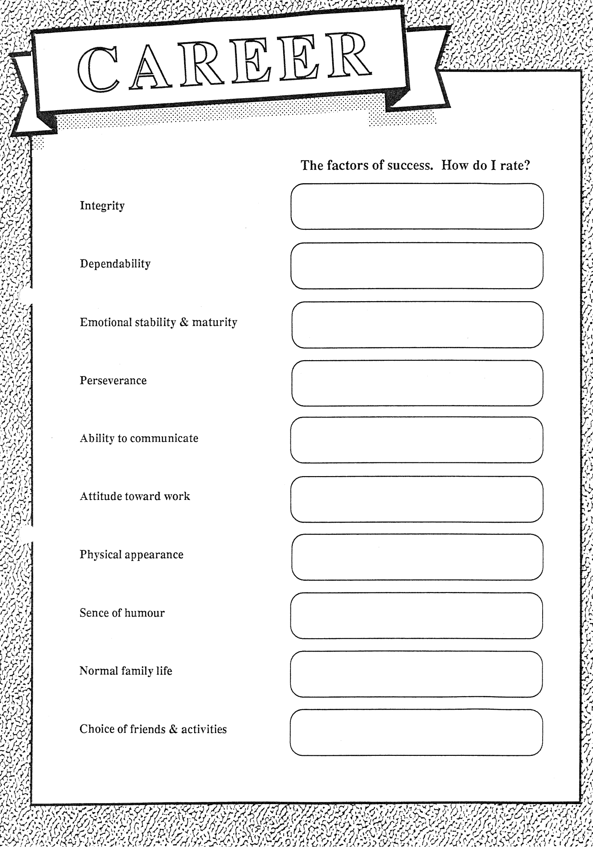
2. Write what influence your choice of attitude, using the Bible/Spirit of Prophecy. (Continue on the back if required)

________________________________________________________________________________________________________________________________________________________________________________________________________________________________________________________________________________________________________________________________________________________________________________________________________________________________________________________________________________________________________________________________________________

