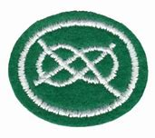

COMPANION CLASS
KNOT TYING WORKSHEET
- What is a knot?.............................................................................
………………………………………………………………………………………………….

- Define the following terms?
a. Working end………………………………………………………………………….
b. Standing end…………………………………………………………………………
………………………………………………………………………………………………….
c. The Bight……………………………………………………………………………….
………………………………………………………………………………………………….
d. The standing part…………………………………………………………………..
………………………………………………………………………………………………….
e. The loop………………………………………………………………………………..
…………………………………………………………………………………………………

- Label the parts of the rope?
- 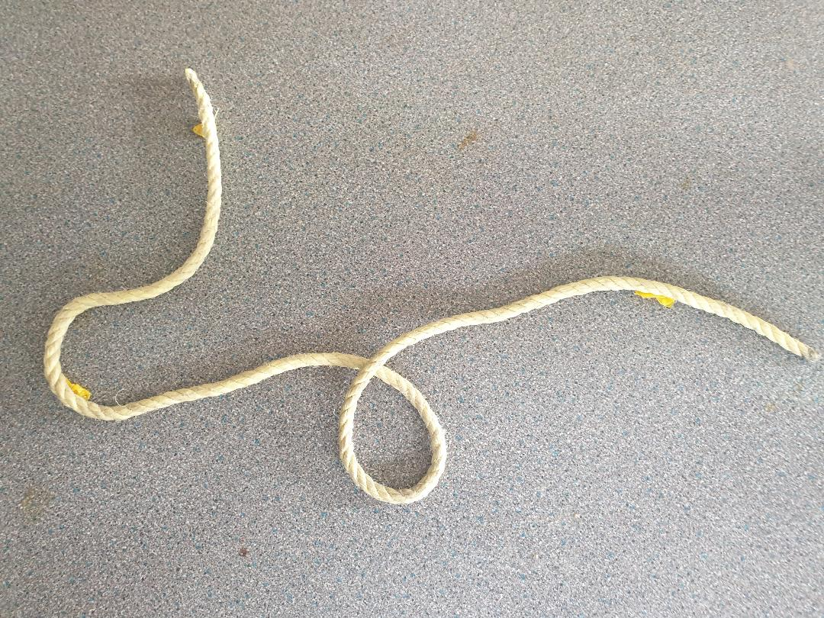

IDENTIFY THE FOLLOWING KNOTS

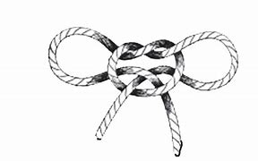…………………………………………………

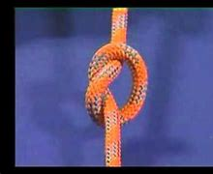……………………………………………………..

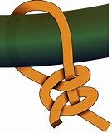……………………………………………………….
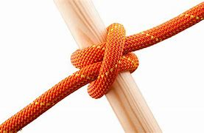………………………………………………………

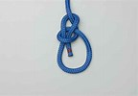……………………………………………………..
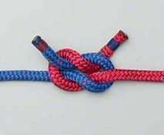……………………………………………………..
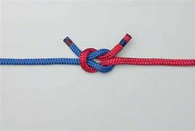……………………………………………………….

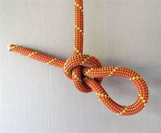……………………………………………………………
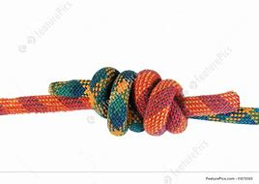………………………………………………………….

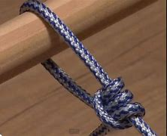………………………………………………………..

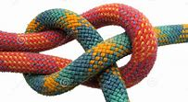………………………………………………………..

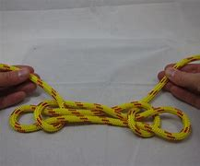……………………………………………………….
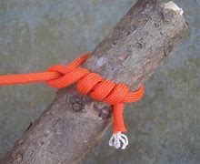…………………………………………….
MATCH THE KNOTS TO THEIR USES/ PUT THE NUMBERS ON THE DOTTED LINES

…………. Join ropes of unequal thickness.
…………. 1. Reduce the length of a cord without cutting and joining
2. Strengthened the portion of a cord which has become weakened.
…………. Hold together logs, firewood or poles temporarily.
…………. A stopper knot/ Stop a rope from fraying.
……………Hitch a horse to a post and securing tent ropes to a peg.
……………Used in first aid bandaging.
……………. 1.The rescue knot
2. Staking out an animal.
………….. Used in packaging.
………….. Shoelace knot.
…………. Begin and end lashings.
………….. 1.Tying ropes to a trailer.
2.Securing tent ropes to a peg.
…………. Tensioning guy lines.
…………. Joining two lines.

- Double bow knot
- Taut line hitch
- Bowline
- Slip knot
- Two half hitches
- Timber hitch
- Clove hitch
- Fisherman knot
- Square/Reef knot
- Granny knot.
- Overhand knot.
- Sheep bend
- Sheepshank

WHAT DOES THE LAW OF KNOTS STATES?...........................................................................................

