Health and Fitness: - 2

- What are the main principles of a healthy diet?

- Complete the diagram to show pictures of food from the five basic food groups.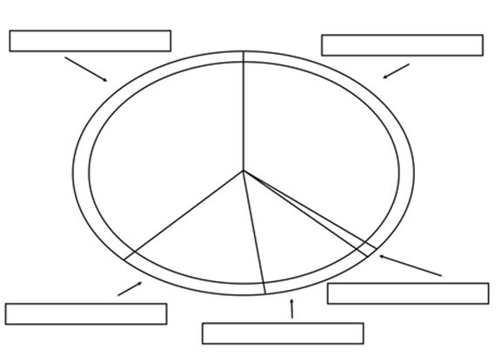
- Plan a 3-day vegetarian menu based on God’s original instruction found in Genesis 1:29.
