OFFICER | JOB DESCRIPTION
Pastor
Elder
Treasurer
Stewardship
Personal Ministries
Deacon
Deaconess
Prayer Ministries
Pathfinders & Adventurer
Children’s Department
Youth Ministries
Men’s Ministries
Women’s Ministries
Health and Safety
Safeguarding
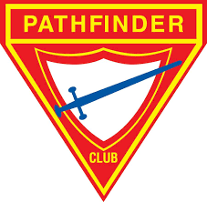
SEC PATHFINDERS CURRICULUM CAMP 2021
VOYAGER CLASS
ORGANISATION AND LEADERSHIP DEVELOPMENT: CHURCH ORGANISATION
NAME: CLUB:

SEC PATHFINDERS CURRICULUM CAMP 2021
VOYAGER CLASS
ORGANISATION AND LEADERSHIP DEVELOPMENT: CHURCH ORGANISATION (Continued)
NAME: CLUB:
OFFICER | JOB DESCRIPTION
Sabbath School
Social Coordinator
Education Lead
Religious Liberty
Church Clerk
Health Ministries
ADRA
Communications Dept

Class Leader: Sign:
Date:
Note: You can personalise it based on your local church set-up
Please complete and submit to your club leader/instructor/counsellor for signing
Retain a copy for your file

