Pathfinder Class Requirement Worksheet
SEC Curriculum Camp held 22-23 June, 2021

Class: Date: Name:
Requirement: Nature Study - Review the story of the flood and study at least 3 different fossils; explain their origin and relate them to breaking God’s law.

Fossils – An Introduction

1. What are fossils?

2. What are fossils made from?

3. Give two examples each of microfossils and macrofossils.

4. What is the process of remains becoming fossils called?

5. What needs to happen for an organism to be fossilized?

6. Name at least 2 places where fossils may be found.

7. Name at least 2 types of fossils. Give examples of each.

8. What is the academic discipline that studies fossils called?

9. What are those who study fossils called?

10. What are some of the things can we learn about plants and animals from their fossils?

Fossil Fuel - Petroleum
11. Petroleum is a fossil fuel. Name two others.

12. What is petroleum formed from?

13. Most oil producing nations of the world belong to what organisation?

14. Name two uses of Petroleum.

15. What are some of the adverse effects of Petroleum consumption?

16. What are some new technology or alternatives being developed as supplements to the petroleum industry?

Bone Fossils – Skeletons/bone
Fossil Evidence | Clues to……..
Serrated teeth (jagged or sawlike edge)

Extremely long neck

Bones not fully developed

Marks on bones

Two different types of bones together

Clam shells inside a rib cage

Leaf Fossil – Gingko Bilboa

18. Where can we find fossil leaves?

19. What important information to paleoclimate studies doe fossil leaves hold?

20. What is the critical connection between the fossil leaves and the records of CO2 variation?

21. By comparing the fossil record for Gingko with what it looks like today, will you say it is degenerating or evolving? Explain your answer.
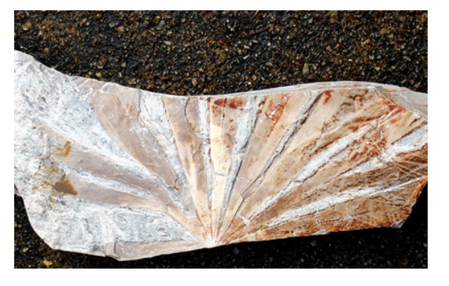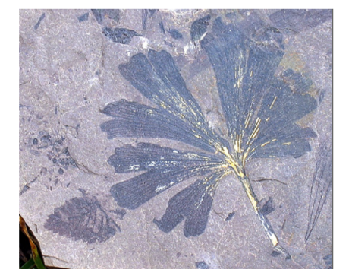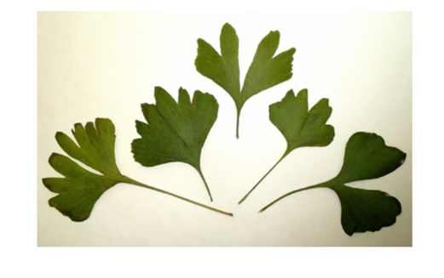

The Flood Story
22. How long ago do evolution scientists say fossil bones date back to?

23. Label and date the diagram below to show the age of the earth according to Bible genealogies.
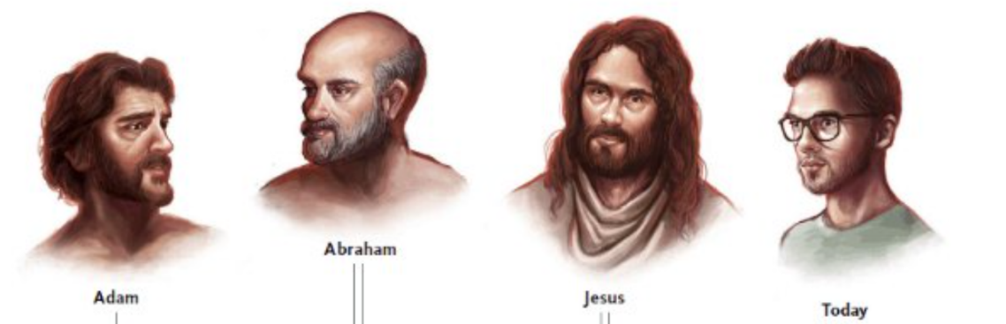

24. What catastrophic global event in the earth’s history recorded in the Bible would have produced vast sedimentary deposits in a much shorter period of time than the 100s of millions of years that evolution science teaches? Where in the Bible is it recorded?

25. Why did God bring a flood of water upon the earth? Genesis 6:5-7

26. How many people were saved from the destruction of the waters of the flood? Genesis 6:8, 18-18 & 1 Peter 3:20

27. How long did it rain during the flood? Gen 7:17

28. What is the sign of the covenant that God made after the flood with Noah and his descendants after him? Gen 9:12-17

Personal Application
29. How did Jesus say the days before His second coming will compare with the days of Noah before the flood? Matthew 24:12, 36-39.

30. Seeing all the signs around us as foretold, what is our duty and how are we to prepare for Jesus’ coming? Ecclesiates 12:13 & James 1:12

