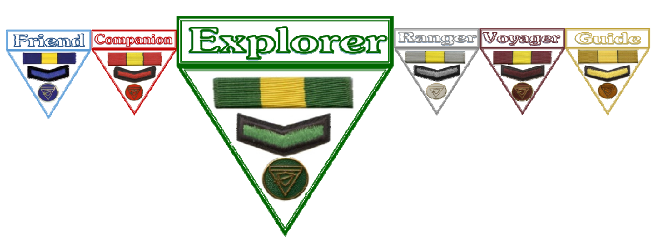

Explorer Spiritual Discovery 5 Name

Proverbs 20:1 (New King James Version)
Fill in the blanks
Wine is a ………………………, Strong …………………….. is a …………………………,
And whoever is led ………………………. by it is not ………………………….
Proverbs 23:29-32 (New King James Version)
Fill in the blanks
29 Who has _____________?
Who has ________________?
Who has ____________________________?
Who has ____________________________?
Who has ________________without ________________?
Who has ________________ of ____________________?
30 Those who ____________ long at the ______________,
Those who go in __________________of _______________wine.
31 Do not ______________ on the _______________ when it is red,
When it ___________________ in the cup,
When it swirls around ____________________________;
32 At the ________________it bites like a _______________,
And _____________________like a __________________________.
List 5 negative effects of Alcohol

Make an Alcohol Poster (on the subject of temperance)

