Nature Study

Review the story of Nicodemus and relate it to the life cycle of the butterfly and label a life-cycle chart of the caterpillar giving the spiritual significance.

Scripture Reference: John 3

- Who was Nicodemus?
_________________________________________________________________________________________________________________________________________________________

- Why did Nicodemus visit at night?

_________________________________________________________________________________________________________________________________________________________

- Meaning of ‘to be born again’?

_________________________________________________________________________________________________________________________________________________________

- Meaning of ‘to be born of water and of the spirit’ (verse 5)?

_________________________________________________________________________________________________________________________________________________________

- Why is there a reference to the ‘wind’ in verse 8?

_________________________________________________________________________________________________________________________________________________________

- Why did Jesus mention the serpent held up by Moses in the wilderness in verse 14?

_________________________________________________________________________________________________________________________________________________________

- What is the meaning of John 3:16?

_________________________________________________________________________________________________________________________________________________________

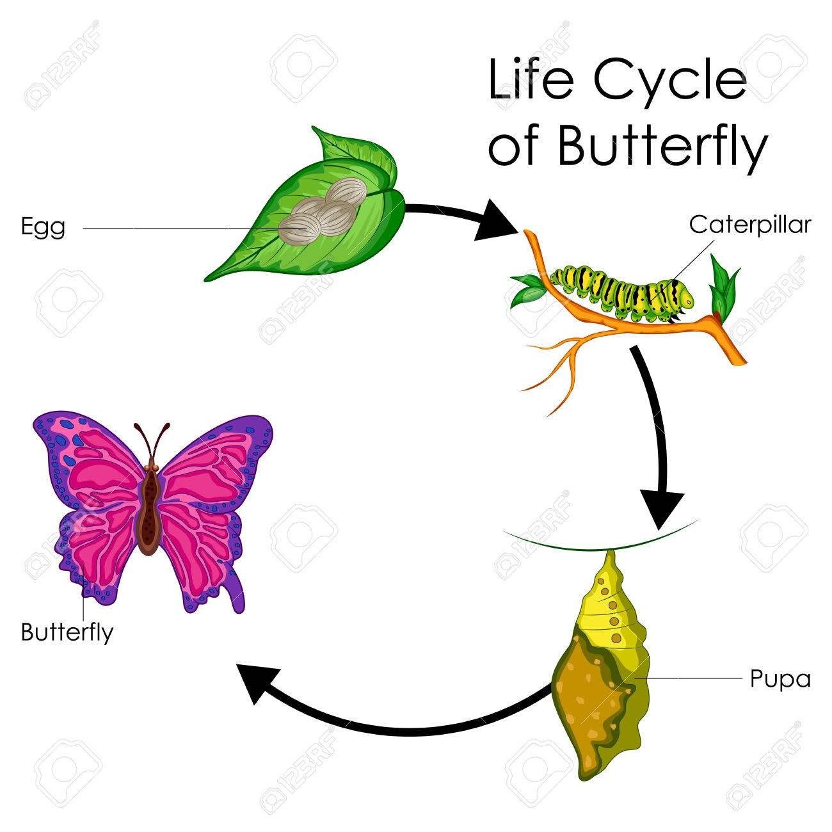

- Describe the following stages of the lifecycle of the butterfly and the spiritual significance as it relates to the story of Nicodemus:

Egg:

________________________________________________________________________________________________________________________________________________________________________________________________________________

Larva:

________________________________________________________________________________________________________________________________________________________________________________________________________________

Pupa:

________________________________________________________________________________________________________________________________________________________________________________________________________________

Butterfly:

________________________________________________________________________________________________________________________________________________________________________________________________________________

9. What has the story of Nicodemus taught you?

