Fossils and The Flood

A Summary of the Flood Story:

The descendants of Adam and eve began to multiply and spread throughout the Earth.
However, men were _ _ _ _ _ _ _ and _ _ _ _ _ _ _ , just like Cain.
God, witnessing the wickedness of men, regretted His decision.
But there was a man known as _ _ _ _ , who was fair and honest.
Noah was one with the _ _ _ _ of God.

God then spoke to Noah, an ordered him to build a large
_ _ _ _ _ _ _ _ _.
The Great Boat would have to be 135m long, _ _m wide, and 13.5m tall.
The Ark would be spilt into different _ _ _ _ _ _ _ _ _ _ _ _, and sealed with pitch.
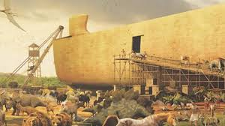
Then God told Noah that He would _ _ _ _ _ _ _ all that existed on Earth, and the creatures that live on it would also _ _ _ _ _ _.

God declared that He would summon a _ _ _ _ _ _ _ _ _ _, saving Noah and his family from it, forming an alliance with them.
God ordered Noah to bring a _ _ _ _ _ _ of every creature into the Ark.
The Ark would also store food for the maintenance of the
animals.
Noah _ _ _ _ _ _ God’s commands.
Therefore, two animals of every kind came to Noah and boarded his Ark.
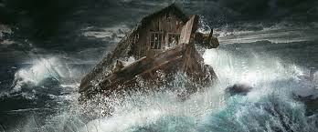
The Great Flood, promised by God, began; _ _ days and 40
_ _ _ _ _ _ of uninterrupted rain.
The Great Ark floated on the waters and even the great mountains submerged when confronted with such a massive torrent.
All _ _ _ and _ _ _ _ _ _ _ _ _ who lived on earth perished, only those on the Ark survived.
The waters covered the Earth for _ _ _ _ _ _ _ straight.
Only after that, the floods of Heaven were closed, and the flood waters began to recede.
3 types of Fossils:
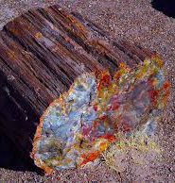

Plant Fossil:__________________

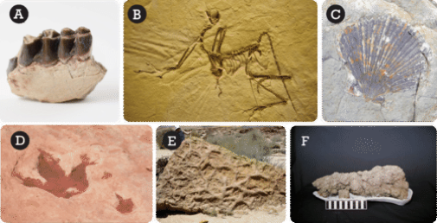

Animal Fossil:__________________
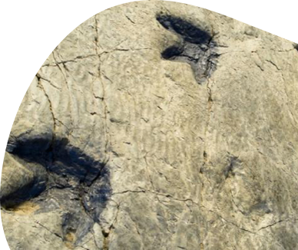

Trace Fossil:__________________

Explain their origin and relate them to breaking God's Laws.

