FRIEND CLASS – FRIENDSHIP DEVELOPMENT

Name:……………………………………..

1. List ten qualities of being a good friend, and discuss four everyday situations where you have practiced the “Golden Rule”.

10 Qualities of being a good friend – A good friend is…..

……………………………………………………. ………………………………………………
……………………………………………………. ………………………………………………
……………………………………………………. ………………………………………………
……………………………………………………. ………………………………………………
……………………………………………………. ………………………………………………

The “Golden Rule”
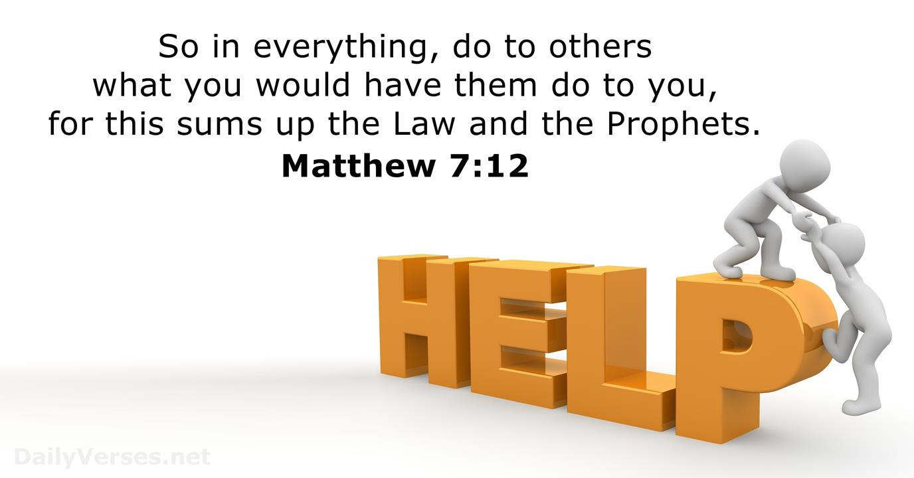

When do you treat others as you want to be treated ?

1. ………………………………………………………………………………………………………..
2. ………………………………………………………………………………………………………..
3. ………………………………………………………………………………………………………..
4. ………………………………………………………………………………………………………..

