Pam Catchpole
FRIENDS
WATER PURIFICATION
SEC E-CURRICULUM CAMP

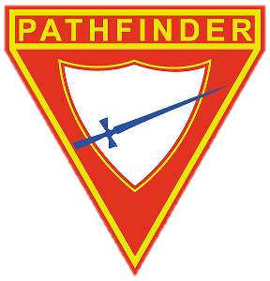

Water purification

1. Name and write in your own words two Bible verses that mention or give reference to Jesus as the water of life

- ---------------------------------------------------------------------------------------------------------------------------------------------------------------------------------------------------------------------------------------------------------------------------------------------------------------------------------------------------------------------------------------------------------------------------------------------------------------------------------------------------------------------------------------------------------------------------------------------------------------------------------------------------

- -----------------------------------------------------------------------------------------------------------------------------------------------------------------------------------------------------------------------------------------------------------------------------------------------------------------------------------------------------------------------------------------------------------------------------------------------------------------------------------------------------------------------------------------------------------------------------------------------------------------------------------------------
2. What is water purification and why do we purify our water?

--------------------------------------------------------------------------------------------------------------------------------------------------------------------------------------------------------------------------------------------------------------------------------------------------------------------------------------------------------------------------------------------------------------------------------------------------------------------------------------------------------------------------------------------------------------------------------------------------------------------------------------------------------------------------------------------------------------------------------------------------------------------------------------------------------------------------------------------------------------------------------------------------------------------------------------------------------------------------------
3. What are the five categories of contaminates found in water?
1.
2.
3.
4.
5.

4. identify five ways in which water can be purified
1.
2.
3.
4.
5.

5. Draw and label a diagram of a home- made water filtration system that you could make that would provide you with clean water in an emergency.

6. Explain the importance of clean water for good health.

------------------------------------------------------------------------------------------------------------------------------------------------------------------------------------------------------------------------------------------------------------------------------------------------------------------------------------------------------------------------------------------------------------------------------------------------------------------------------------------------------------------------------------------------------------------------------------------------------------------------------------------------------------------------------------------------------------------------------------------------------------------------------------------------------------------------------------------------------------------------------------------------------------------------------------------------------------------------------------------------------------------------------------------------------------------------------------------------------------------------------------------------------------------------------------------------------------------------------------------------------------------------------------------------------------------------------------------------------------------------------------------------------------------------------------------------------------------------------------------------------------------------------------------------------------------------------------------------------------------------------------------------------------------------------------------------------------------------------------------------------------------------------------------------------------------------------------------------------------------------------------------------------------------------------------------------------------------

