Ranger Class
FRIENDSHIP DEVELOPMENT:

Requirement 1
In group discussion and by personal inquiry, examine your attitudes to the following topics:
1: Friendship;

Why do we have friends? ……………………………………………………………………………………………………………………………………………………………………………………………………………………………………………………………………………………………………………………………………………………
What is friendship?
……………………………………………………………………………………………………………………………………………………………………………………………………………………………………………………………………………………………………………………………………………………

Friendship Pyramid
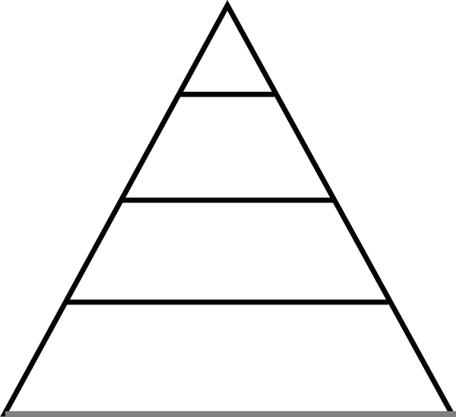

Bible Principles Relating to Friendship: Fill in the blanks

Proverbs 17: 17 NIV
A ………………. loves at all times, and a brother is born for a time of adversity. A …………………. loves at all times, and a brother is born for a time of adversity.

Proverbs 18-24 (NIV) 18
An………………………………………………….. pursues selfish ends and against all sound judgment starts quarrels.

2: The Social Graces

What does the word etiquette mean?
……………………………………………………………………………………………………………………………………………………………………………………………………………………………………………………………….

Discussion

- What do you do when you yawn, cough, or sneeze in company?
………………………………………………………………………………………………………………………………………………………………………………………………………………………………………………
- How should you treat elderly people?
………………………………………………………………………………………………………………………………………………………………………………………………………………………………………………
- When should you write a “thank you” letter or note?
………………………………………………………………………………………………………………………………………………………………………………………………………………………………………………
- What is the worst example of bad manners you have ever seen? What is the worst breach of etiquette of which you have been guilty?
………………………………………………………………………………………………………………………………………………………………………………………………………………………………………………………………………………………………………………………………………………………………………………………………………………

- What should you try to avoid if you are bored when you are with other people?
………………………………………………………………………………………………………………………………………………………………………………………………………………………………………………………………………………………………………………………………
- Give some examples of breaches of etiquette you have observed this week.
……………………………………………………………………………………………………………………………………………………………………………………………………………………………………………………………………………………………………………………………..
- Why is it important to know the rules of etiquette and to practice them?
………………………………………………………………………………………………………………………………………………………………………………………………………………………………………………

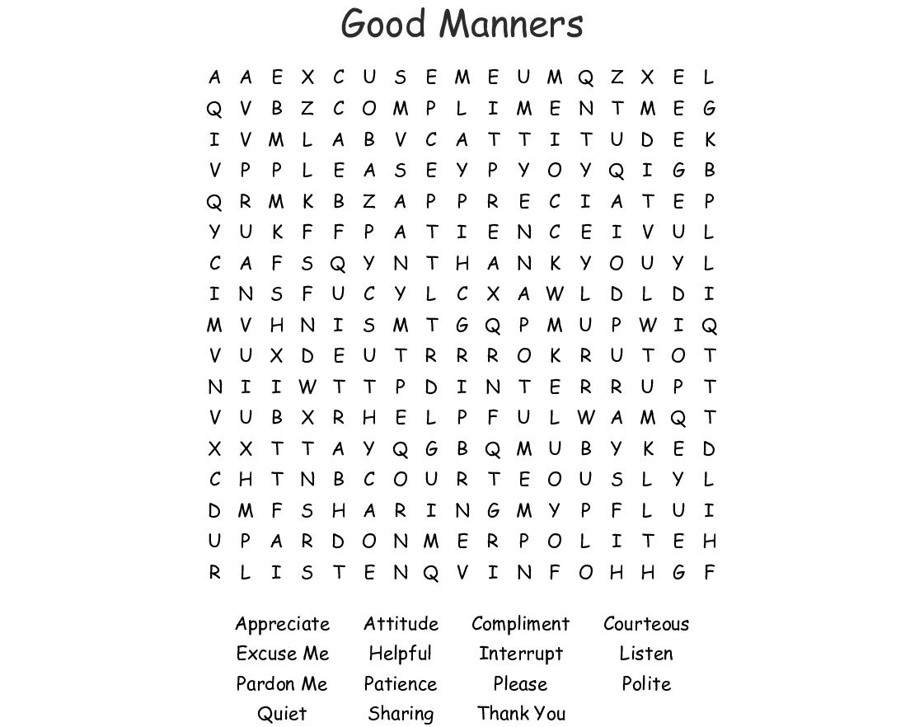
Table Manners:

