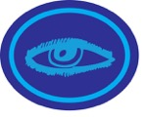 SIGHT HONOUR WORKSHEET

Completed by:
Date Started: / / Date Completed: / /
“I praise You because I am fearfully and wonderfully made; your works are wonderful; I know that full well.” Psalm 139:14

- (a) Perform this activity. Be blindfolded. Let someone place an item between 15 metres to 20 metres away from you. Now search for the item. Record the time you found the item. Now, be blindfolded again. Let someone place the item somewhere else but within the same distance as before. Take of your blindfold. Search for the item. Record the time you found the item.

 | Distance of item from you (metres) | Time you found the item (seconds)
When blindfolded
When not blindfolded

(b) Watch the video: https://youtu.be/syaQgmxb5i0. Now answer the following questions:

What is the sense of sight used for? How important is it? __________________________________________________________________________________________________________________________________________________________________________________________

- How big is the human eye?

- Anatomy of the eye. Label the parts.
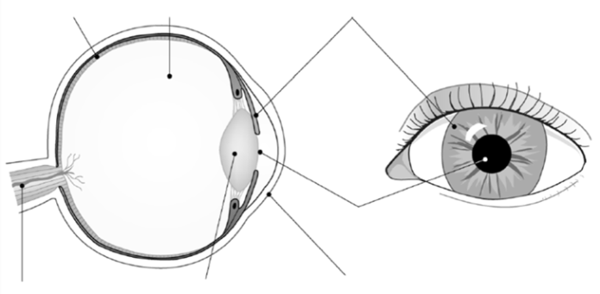

http://www.kscience.co.uk/animations/eye_function_drag.htm
Click on the link provided above and do the exercise on the functions of the parts of the eye. The work will look like the one below. When complete check your answer. The system will then mark your work. Print and paste your work over the one below.

- How does a lens work? Complete the sentence below using the words from the box.

We have a lens in each of our _______________. This is a ______________ lens. The job of this lens is to ______________ the ________________ so we can_____________________. The point at which the rays cross is called the focus or the ____________________. The light is ________________________as it goes into the and as it comes back out.

eyes refracted light focal point

focus see convex

- Watch video:

(a) Below are the steps in how humans see.
Arrange them in a chronological order by putting numbers (1,2,3,4,5,6) in the “position” column to reflect the right order in which they should be

Position | Steps
 | When you look at an object. Light reflected from the object goes through the pupil of your eye.
 | Your brain sorts the image out so you see it the right way round.
 | The cornea and the lens focus the light onto the retina.
 | An inverted image is formed on the retina. The retina is made of light sensitive cells called photoreceptors.
 | The iris, a muscle that controls the size of the pupil, allows the correct amount of light to enter your eye.
 | When the image forms on the photoreceptors in the retina, chemical reactions produce and electrical impulse that travels up the optic nerve to your brain.

(b) Fill in the blanks: A medical doctor who specialises in examining, diagnosing and treating eyes and eye diseases is called a/an

(c) Visual acuity test, Visual field test and Tonometry test are tests that an ophthalmologist performs on the eye.

Match the name of the term to its meaning
A person reads an eye chart to measure how well he or she sees at various distances.
Visual acuity test

This test determines the fluid pressure inside the eye to evaluate for glaucoma
Visual field test

Ophthalmologists use this test to measure side, or peripheral, vision
Tonometry test

(d) What are the roles of:
(i) Rods: ___________________________________________________________________

((ii) Cones: __________________________________________________________________

__________________________________________________________________

- How does the eyesight of humans compare with other creatures? (Compare with any three of the following animals: eagles, owls, mantis shrimp, deer, goat, horse, elk, sheep, goat). Write the name of the animal on the line.

Humans vs ___________________

Humans vs ____________________

Humans vs ______________________

Feature in a camera  7 (a) Compare the key features of the eye and a camera by finishing the table below | Feature in an eye | Use
 | pupil
Lens
Shutter
 | retina | Receives light

(b) Write a paragraph below to compare how the eye and the camera work. Cover the following factors in your answer:
- Similarities: What features do they have in common? What does each convert the light energy into when it is processed? Which way up does the image form in both?
- Differences: How does the lens change in each to produce an image? How do the types of image made by each compare? How are the images captured and kept?

_________________________________________________________________________________

_________________________________________________________________________________

_________________________________________________________________________________

_________________________________________________________________________________

_________________________________________________________________________________

_________________________________________________________________________________

_________________________________________________________________________________

_________________________________________________________________________________

- With reference to the eye chart explain:
(a) 20/20 Vision

___________________________________________________________________________

___________________________________________________________________

- 20/70 Vision: _______________________________________________________________

___________________________________________________________________

- What is visual impairment?

- Define these eye problems and state their ‘cures’.

a. Glaucoma
b. Cataracts
c. Strabismus
d. ‘Sore eyes’/conjunctivitis
d. Colour blindness

.
Glaucoma: __________________________________________________________________

___________________________________________________________________
___________________________________________________________________
___________________________________________________________________

.

Cataracts: ___________________________________________________________________
_________________________________________________________________________________

_________________________________________________________________________________
_________________________________________________________________________________
Strabismus: ___________________________________________________________________

___________________________________________________________________
___________________________________________________________________

Conjunctivitis:
___________________________________________________________________
___________________________________________________________________
___________________________________________________________________

Colour blindness: _________________________________________________________________
_________________________________________________________________________________
_________________________________________________________________________________

- (a) Fill in the blanks: (Watch the video - https://youtu.be/ypF037wlYZg)

- ________________ is the bending of light when it passes through a transparent medium such as glass, lens or water.

- The refractive errors are _______________, ___________________, ____________ and _______________.
- _________________is also known as near-sightedness. People with this have eyes that are a little longer than normal, measuring from the front of the eyeball to the back. Therefore, light focuses in front of the retina instead of on it.
- ___________________ is also known as farsightedness. People with this have trouble focusing on things close up because their eyes are too "short" from front to back. Therefore, light focuses behind the retina instead of on it, causing blurry vision.
- _____________________ is a condition in which your eye isn’t completely round. Therefore, light gets bent more in one direction than another. That means only part of an object is in focus so things at a distance may look blurry and wavy.

- _________________ is the normal loss of near focusing ability that occurs with age. Most people begin to notice the effects of presbyopia sometime after age 40, when they start having trouble seeing small print clearly.

- Read Genesis 48:10. Which of the refractive errors did Israel have? _____________________

- State if the statement below is true or false. Underline the correct answer.
“All the refractive errors can be corrected by wearing the right glasses or contact lens” TRUE / FALSE

- Eye care:
{a} How should I clean my eyes? Look at the picture and write a single sentence in the notes column to explain what happens at each stage of the eye cleaning process. The first one has been done for you.

Picture | Notes
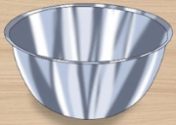 | Get a bowl
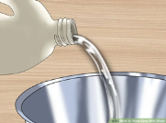
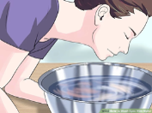
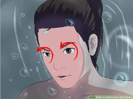
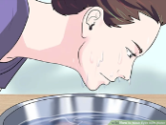
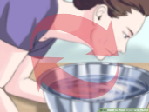
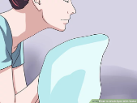

{b} Write one sentence on how we can strain our eyes?

{c} How do we rest them? Look at the picture and write a single sentence in the notes column to explain how to rest our eyes. The last one has been done for you.
Picture | Notes
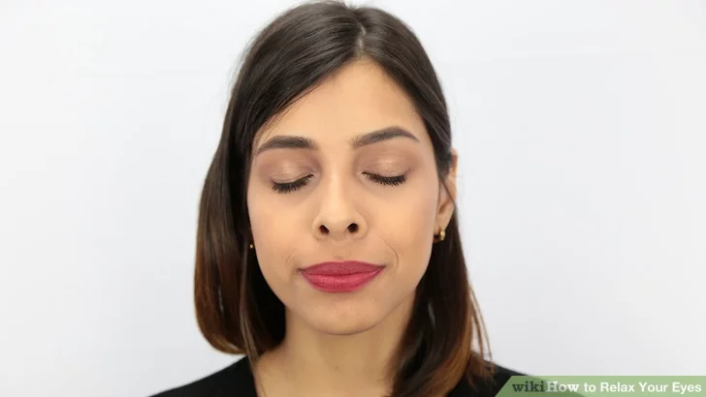
 | Try relaxation eye exercises.

(d) Matthew has been using a computer continuously for 4 hours! Now he is complaining of eye strain. Give Matthew three pieces of advice to help him relax his eyes.

- ________________________________________________________________

- ________________________________________________________________

- ________________________________________________________________

(e) Explain the 20-20-20 rule of eye relaxation.

___________________________________________________________________
___________________________________________________________________ {f} What do I do if I cannot see very well?

__________________________________________________________________________
__________________________________________________________________________

- Give two meanings to the expression “The eyes are a window to the soul”?

- ______________________________________________________________
______________________________________________________________

- ______________________________________________________________
______________________________________________________________

- What are the effects of exposing ourselves to watching:

- violence/pornography (mention three)
- ______________________________________________________________
- ______________________________________________________________

- ______________________________________________________________

- Video games: Use the table to give three advantages and disadvantages

 | Advantages | Disadvantages
1
2
3

- Social media: Use the table to give three advantages and disadvantages

 | Advantages | Disadvantages
1
2
3

- Explain 1 Samuel 16:7
________________________________________________________________
________________________________________________________________
________________________________________________________________
________________________________________________________________
________________________________________________________________

- Explain “fixing our eyes on Jesus” (Hebrews 12:2)
__________________________________________________________________________
__________________________________________________________________________
__________________________________________________________________________
__________________________________________________________________________
__________________________________________________________________________

- Mention four ways that life can be made easier for the visually impaired.

- ________________________________________________________________

- ________________________________________________________________

- ________________________________________________________________

- ________________________________________________________________

- Optical Illusion:
- Fill in the blanks using the word bank in the box below the passage.

_____________ Illusions can use colour, ______________ and patterns to create ___________ that can be deceptive or misleading to our _____________. The information gathered by the eye is processed by the brain, creating a perception that in reality, does not match the true image. Perception refers to the interpretation of what we take in through our _____________. Optical illusions occur because our brain is trying to _______________ what we see and make sense of the world around us. Optical illusions simply trick our brains into seeing things which may or may not be _____________.

images eyes brains optical real light interpret

- Provide the answers to the optical illusions below:

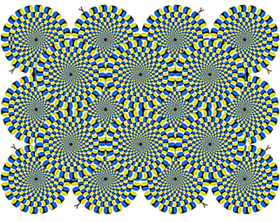
Snakes:
Are the circles moving in the image?
Answer:
Hermann Grid illusion
How many black dots are in this image?
Answer:

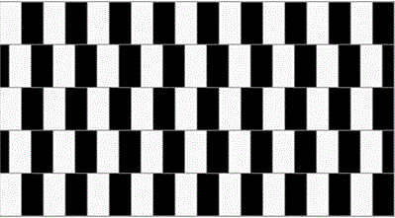
Horizontal lines
Are the horizontal lines sloping or straight?
Answer:
Muller-Lyer Illusion
Take a very close look at the 2 vertical lines. Do you think one line is longer than the other?
Answer:

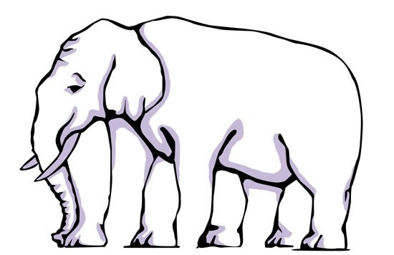
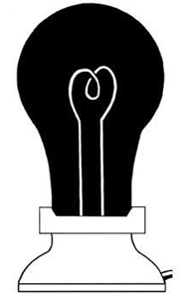
Elephant Legs
How many legs do I have?

Answer:

Answer:
Light Bulb
Stare closely at this light bulb for 25 seconds. Then immediately stare at a white wall or sheet of paper. What do you see?
Answer:

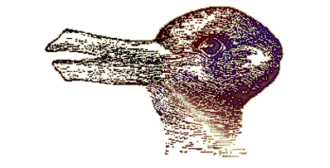
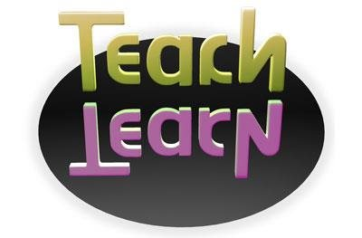
The Animal
How many animals do you see in the image?
Answer:
Teach
In this illusion you can see the word Teach and its reflection. Can you read the reflection too? What does it say?
Answer:

Answer:

20. Watch the video on how to do an origami eye. Make an origami eye. Stick the picture of your origami eye below.

Assessed By:

(Full Name & Rank in Block Letters)

Assessor’s Signature: Date: / /

