TASTE HONOUR WORKSHEET

Completed by:

Date Started: / / Date Completed: / /

What is the Gustatory System?

- Define the word ‘taste’.

- What are the taste buds?

- Name the 5 (FIVE) taste sensations?

On the diagram below identify the indicated parts of the Gustatory System.

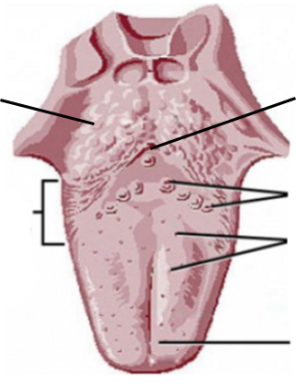

- Explain how taste is related to our other senses?

- Is our taste preference genetically decided or is it trained? Explain.

- What are the treatment options for someone who has lost their sense of taste?

- Quote 5 (FIVE) Bible texts that refer to our sense of taste.
a)

b)

c)

d)

e)

Perform a Blind Taste Test with a minimum of 10 (TEN) foods.

METHOD:
The easiest way is to do this is with a parent, guardian or friend. Have them blindfold you before they prepare the items for tasting to make sure you have no idea what the items are. Of the foods you taste at least 2 should be from each taste sensation category. Taste each item individually. Make sure that your parent, guardian or friend takes notes based on the questions below for each food that you taste. For each item you have 3 guessing attempts. Once the test is complete, fill out your worksheet. If it takes you more than 3 attempts, tick ‘unable to identify’.

- Food Name: Taste Sensation:
Guessed correctly on attempt: /3 Unable to Identify: ☐

- Food Name: Taste Sensation:
Guessed correctly on attempt: /3 Unable to Identify: ☐

- Food Name: Taste Sensation:
Guessed correctly on attempt: /3 Unable to Identify: ☐

- Food Name: Taste Sensation:
Guessed correctly on attempt: /3 Unable to Identify: ☐

- Food Name: Taste Sensation:
Guessed correctly on attempt: /3 Unable to Identify: ☐

- Food Name: Taste Sensation:
Guessed correctly on attempt: /3 Unable to Identify: ☐

- Food Name: Taste Sensation:
Guessed correctly on attempt: /3 Unable to Identify: ☐

- Food Name: Taste Sensation:
Guessed correctly on attempt: /3 Unable to Identify: ☐

- Food Name: Taste Sensation:
Guessed correctly on attempt: /3 Unable to Identify: ☐

- Food Name: Taste Sensation:
Guessed correctly on attempt: /3 Unable to Identify: ☐

Assessed By:

(Full Name & Rank in Block Letters)

Assessor’s Signature: Date: / /

