TOUCH HONOUR WORKSHEET

Completed by:

Date Started: / / Date Completed: / /

- Label and explain the functions of the three main parts of the skin:
Epidermis, Dermis, and Subcutaneous tissue (Hypodermis)

- Define the following receptors in the Somatosensory System that enables the sense of touch:

- Mechanoreceptors

________________________________________________________________________________________________________________________________________________________________________________________________________________________________________________________

- Thermoreceptors

________________________________________________________________________________________________________________________________________________________________________________________________________________________________________________________
- Pain receptors

________________________________________________________________________________________________________________________________________________________________________________________________________________________________________________________

- Proprioceptors

________________________________________________________________________________________________________________________________________________________________________________________________________________________________________________________
- How much of the body does the skin occupy?

________________________________________________________________________________________________________________________________________________________________________________________________________________________________________________________________

- Why is touch important to human interaction and life development?

____________________________________________________________________________________________________________________________________________________________________________________________________________________________________________________________________

- Explain how the sense of touch changes with age.

____________________________________________________________________________________________________________________________________________________________________________________________________________________________________________________________________

- How do you protect your skin and is it affected by different temperatures?

________________________________________________________________________________________________________________________________________________________________________________________________________________________________________________________________

- What is Hypoesthesia? What do you think it would be like to live without a sense of touch?

____________________________________________________________________________________________________________________________________________________________________________________________________________________________________________________________________

- Do cosmetics help or hinder your skin?

________________________________________________________________________________________________________________________________________________________________________________________________________________________________________________________________
- Define the following Skin Disorders/Conditions:

- Eczema
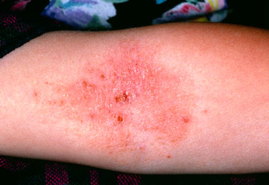

- Actinic keratosis
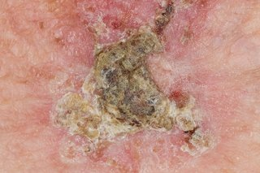

- Rosacea
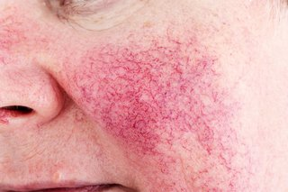

- Warts
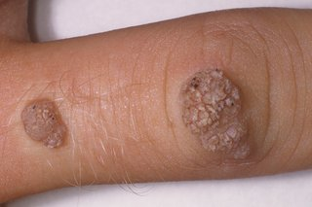

- Cellulitis

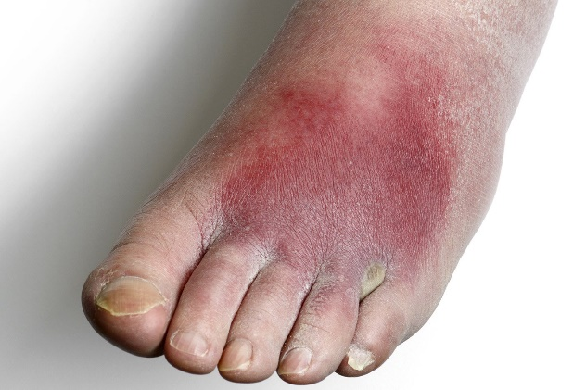

- Psoriasis

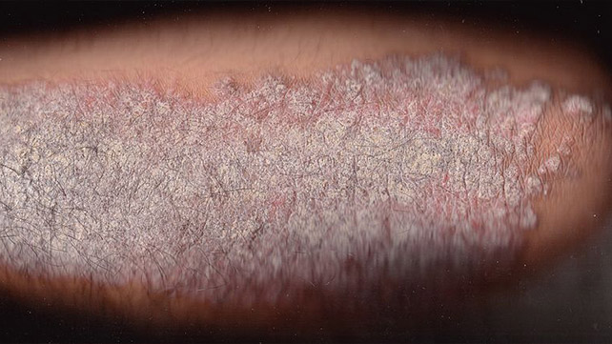

- Explain how tattooing can damage the skin and discuss what the Bible says about marking the body.

________________________________________________________________________________________________________________________________________________________________________________________________________________________________________________________________________________________________________________________________

- Explain how the Bible illustrates touch from each of the following perspectives:

- Defilement - Numbers 19:22 / Leviticus 5:2-3

__________________________________________________________________________________________________________________________________________________________________________________________
- Strengthening and Encouragement - Jeremiah 1:8-9 / Daniel 8:18

__________________________________________________________________________________________________________________________________________________________________________________________

- Healing and Grace – Matthew 8:3 / Mark 5:18-29 / Luke 6:19

__________________________________________________________________________________________________________________________________________________________________________________________

- Sanctification - Isaiah 6: 5 -7

__________________________________________________________________________________________________________________________________________________________________________________________

- Define and know the difference between safe and unsafe touch.

________________________________________________________________________________________________________________________________________________________________________________________________________________________________________________________________________________________________________________________________

- What other areas or parts of the skin are more sensitive than others?

- Explain some ways in which the sense of touch can be used to convey emotions and what percentage of the time can people communicate via touch?

________________________________________________________________________________________________________________________________________________________________________________________________________________________________________________________________

Assessed By:

(Full Name & Rank in Block Letters)

Assessor’s Signature: Date: / /

